**How to make slot imaging**

1. **3D printing**

I.

Print all parts by 3D printer.

All parts prepared by 3D printer

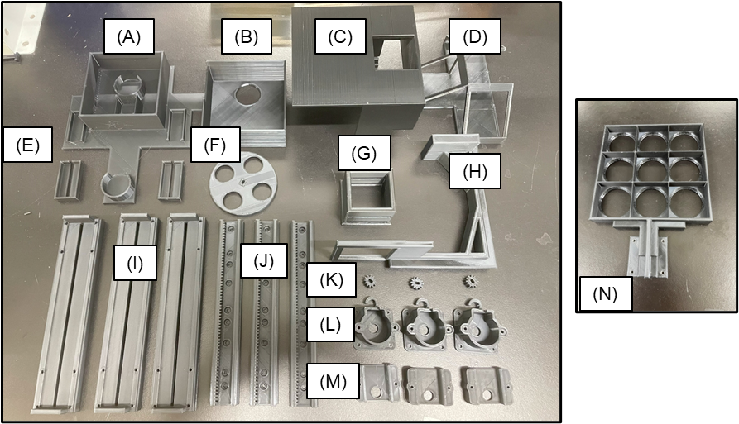

1. Filter box base
2. Filter box lid
3. Separator
4. Light source table
5. Separator fixture
6. Filter table
7. Light stand attachment
8. Light stand base
9. Rack gear base
10. Rack gear
11. Pinion gear
12. Motor box table
13. Motor box base
14. Well table

※Fundamentally set infill value 40 %

1. **Preparation of each parts**

I.

Cut the acrylic board at 20mm from right edge of board and 46mm from top edge of board(Supplementary Fig. 2A).

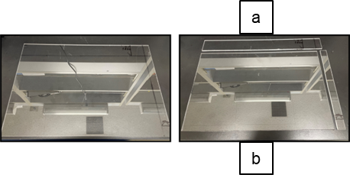

II.

Cut out two 44mm x 46mm squares from a piece of acrylic board “b”. Also cut out two diffusers of the same size. Attach the acrylic board and diffuser to Light stand attachment (Supplementary Fig. 2B, C and D).

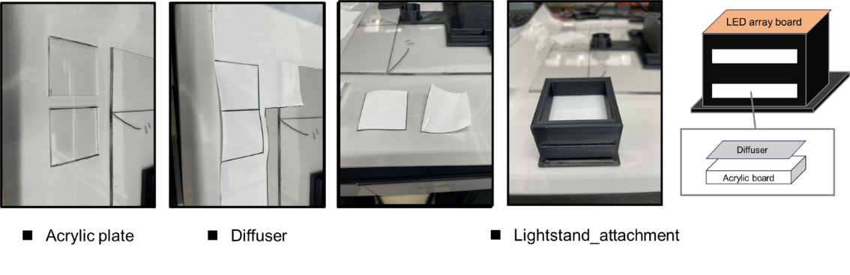

III.

Cut the wires down the middle to extend the wiring for the 28BYJ48 stepping motor and installed the female pin and housing (Supplementary Fig. 2E).

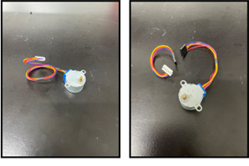

IV.

To guarantee the motor box base can move smoothly in rack gear, install motor box base on rack gear and slide it until it moves smoothly in each set (Supplementary Fig. 2F).

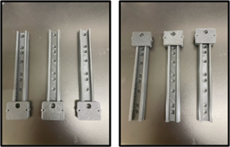

V.

Fit the stepping motor into the gearbox table and fix the gearbox base with 16 mm M3 screws. And then, attach the completed gearbox to the rack gear (Supplementary Fig. 2G).

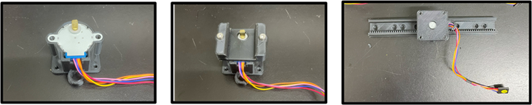

VI.

Fix two motor box tables to the rack gear base with 10 mm M3 screws. Then, after fixing the motor box base with 16 mm M3 screws, install the pinion gear on the shaft of the motor (Supplementary Fig. 2H).

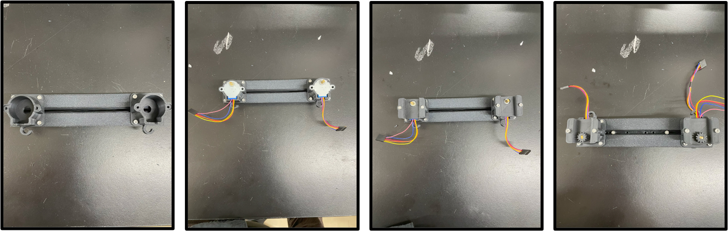

VII.

Fix the created gearbox and pinion gear set to the rack gear base with 12 mm M3 screws and nuts. Then, attach a rack gear to each of the lower gearboxes. Fix the rack gear base to each of the rack gears with 12mm M3 screws and nuts. Then, fix the well table to the upper gear box with a 10 mm M3 screw (Supplementary Fig. 2I).

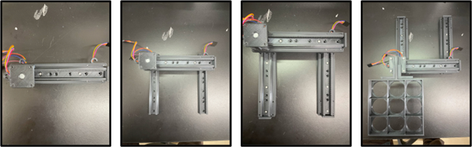

VIII.

To make light source table, totally, 25 Light emitting diodes(LEDs) were soldered on a 50 mm ×70 mm PCB base(Supplementary Fig. 2Ja). In the series direction, LEDs were soldered with one hole skipped. In addition, resistances were soldered on the edge of each LED arrays. In the parallel direction, LED arrays were soldered with two holes skipped. Resistances value which was connected to each LED arrays was calculated using Ohm’s law formula. In addition, and then the anode and cathode of each LED array were connected to a male pin header.

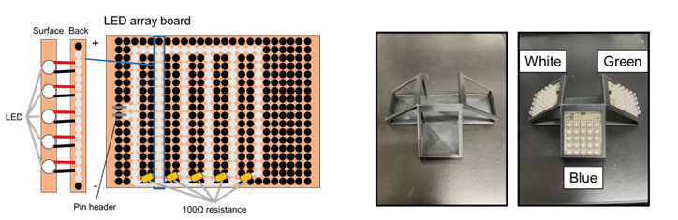

IX.

Excess was cut off and LED array board were install to Light source table (Supplementary Fig. 2Jb)

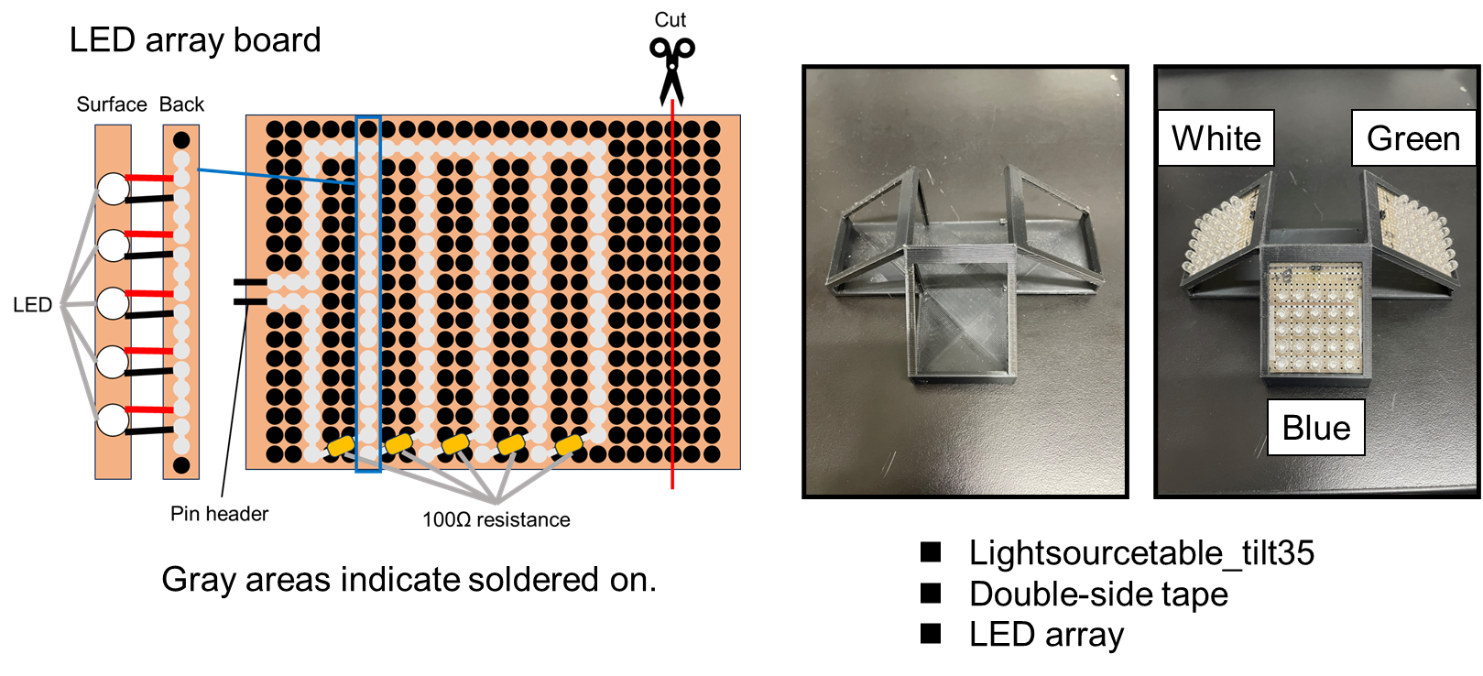

X.

To make power source connector, the anode and cathode portions of the DC Jack were connected via wires to the excess portion cut out when the LED array board was made with soldering. After that, the pin headers were attached with soldering (Supplementary Fig. 2K).

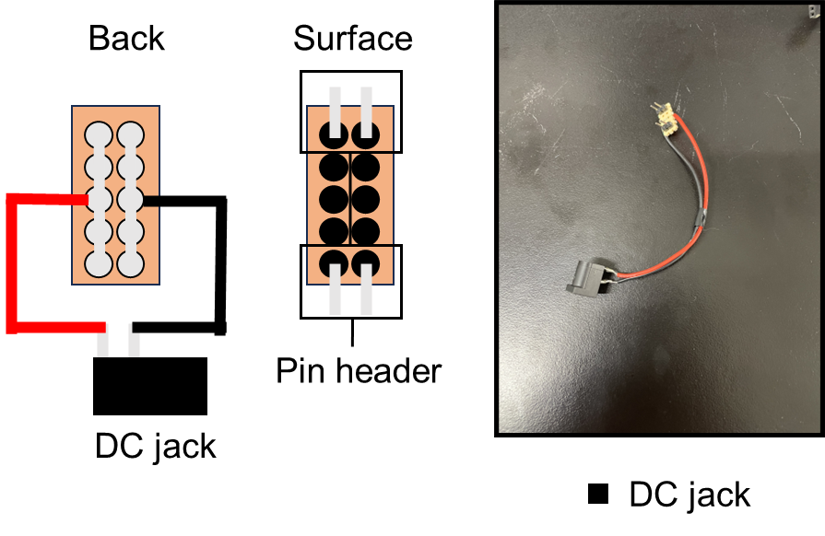

XI.

To make the jumper wire to connect the Raspberry pi to each parts, Totally, Seven jumper wire sets were prepared (Supplementary Figs. 2L and Supplementary Table. 1A). Also, Stickers were labeled 1, 2, 3, 4 on the four relay modules and 1, 2, 2, 3, 3 on the five stepping motor control modules.

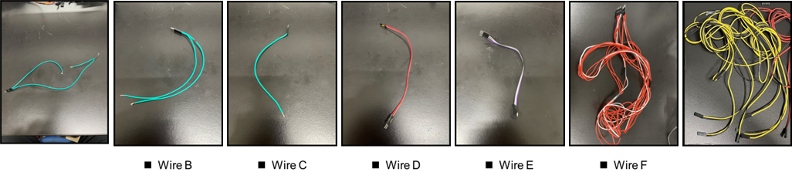



1. **Assembly**

I.

Filter box base was adhered at 6.5 cm horizontally and half-length of plate vertically from the corner of the acrylic plate with double-sided tape (Supplementary Fig. 3A).

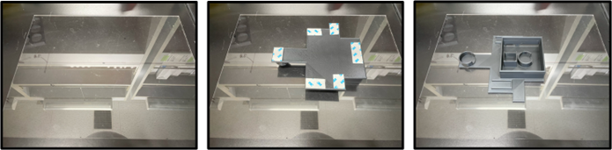

II.

Two stepping motors were adhered on two mounting positions, one inside the filter box and one outside with double-sided tape (Supplementary Fig. 3B).

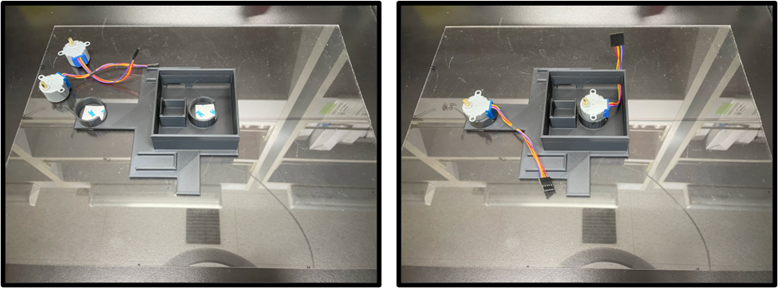

III.

Camera module was connected with connecter for camera (Supplementary Fig. 3C). Camera module was fixed on mounting positions with cellophane tape (Supplementary Fig. 3D)

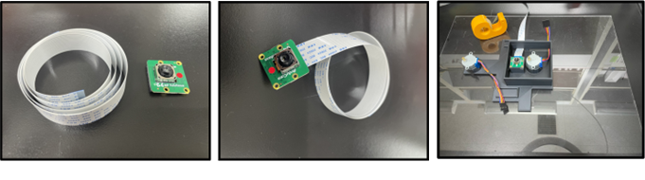

IV.

filter table which two optic filters was fitted on was fixed on the rotary shafts of stepping motor (Supplementary Fig. 3E).

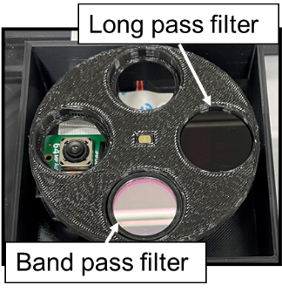

V.

Lid was attached on the filter box and Light source table was attached to the stepping motor mounted outside of filter box (Supplementary Fig. 3F).

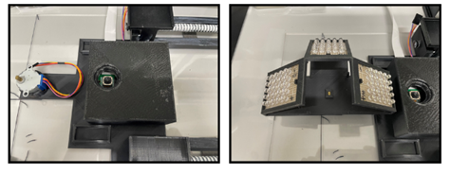

VI.

Glue the dual-axis actuator along the frame of the filter box base by double side tape (Supplementary Fig. 3G).

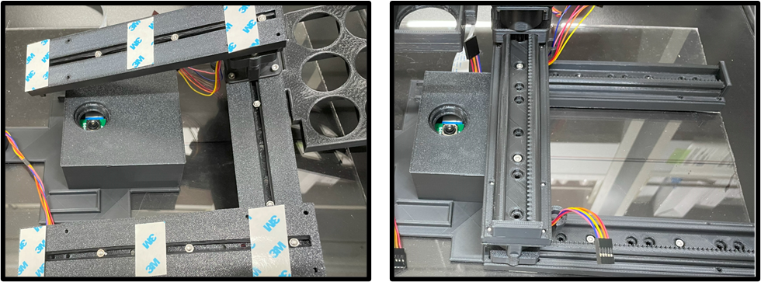

VII.

Install separator and secure with fixture (Supplementary Fig. 3H).

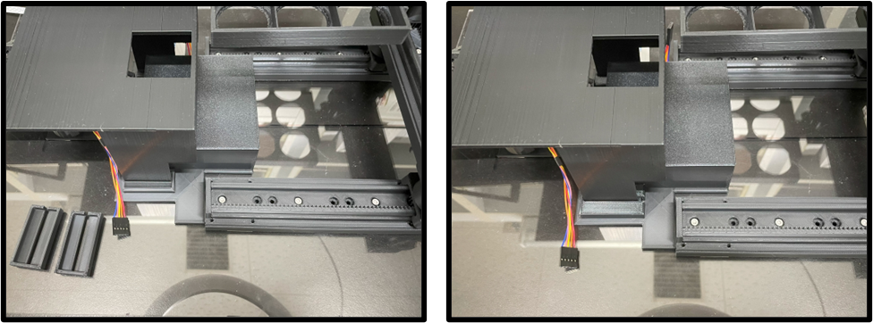

VIII.

Light stand attachment was attached to light stand base and then secure the light stand so that it is aligned with the corner of Filter box base (Supplementary Fig. 3I).

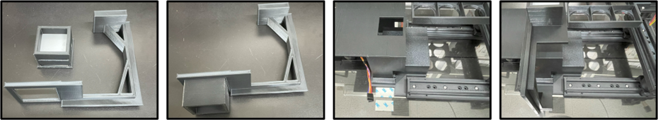

IX.

Apply grease to the dual-axis actuator and slide the motor box to blend. (Supplementary Fig. 3K).

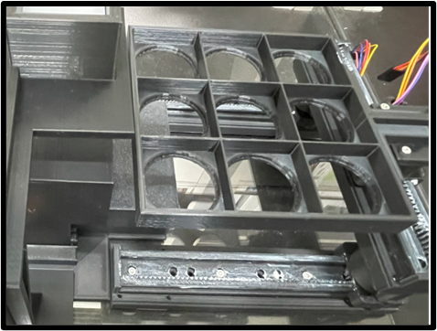

X.

White LED array board was attached to light stand attachment with double-sided tape (Supplementary Fig. 3K).

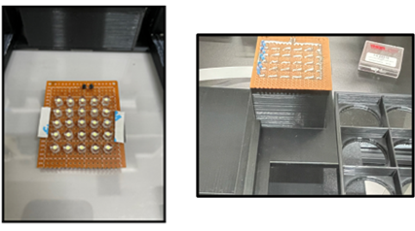

1. **Wiring with relay module**

Wiring position of GPIO pins



I.

18v power was connected to the COM and NC channel of the relay modules via bread board using wire A (Fig. 3D and E) (Supplementary Fig. 4A).

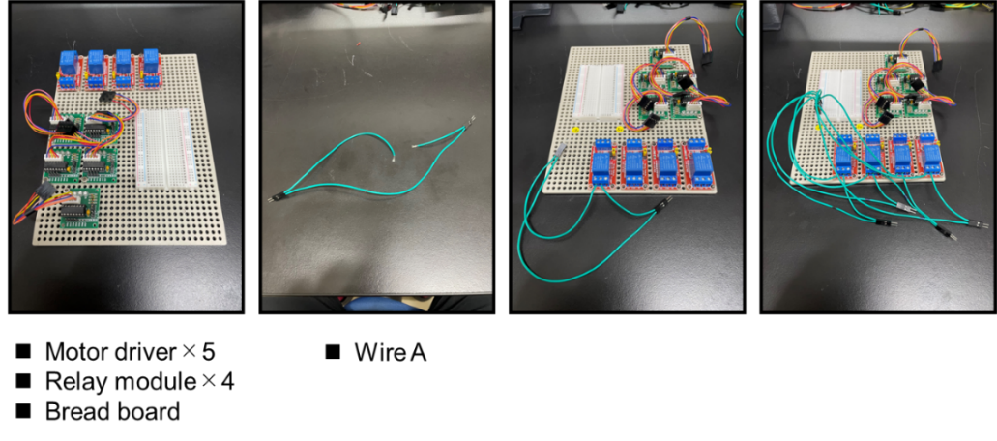

II.

Anode of 5v power was connected to the anode of logic power portion of the relay modules and cathode of 5v power was connected to the cathode of logic power portion of the relay modules via a bread board using wire B (Fig. 3C and E) (Supplementary Fig. 4B).

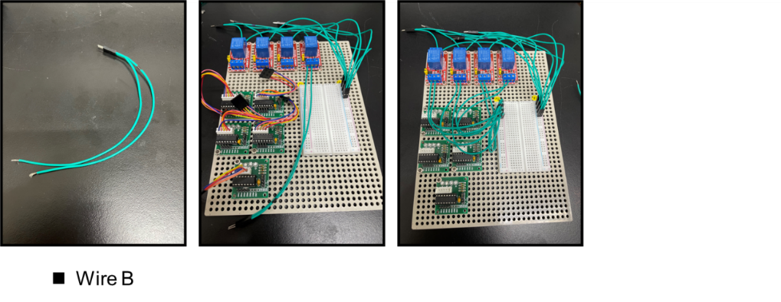

III.

The Raspberry GPIO pins 8, 10, 12 and 16 were connected to input portion of the relay modules via a bread using wire C (bread board pin socket name from i7, i8, i9 and i11 to relay module1, 2, 3 and 4) (Fig. 3F, G, H and I) (Table. 1A) (Supplementary Fig. 4C).

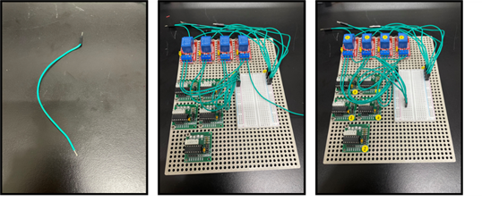

IV.

Anode of LED array boards were connected to anode of 18v power and cathode of LED array boards were connected to cathode of 18v power using by wire G with wire A (relay module1 to white LED, relay module2 to blue LED, relay module3 to green LED, relay module4 to white LED attached to light stand) (Supplementary Fig. 4G). Thereby, all four relay modules were powered by a DC 5 V power-source (Fig. 3C) and All LED array boards were poured by a DC 18 V power source via each relay modules (Fig. 3D) which was opening and closing the DC 18 V circuit. It is possible to turn LED array board ON or OFF under the control of Raspberry pi.

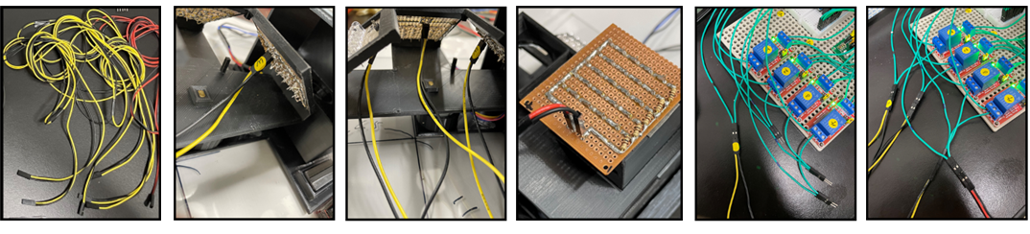

**5. Wiring with stepping motors**

I.

Anode of 5v power was connected to the anode of logic power portion of the stepping motor control module and cathode of 5v power was connected to the cathode of logic power portion of the stepping motor control module via a bread board using wire D (Fig. 3E) (Supplementary Fig. 4D).

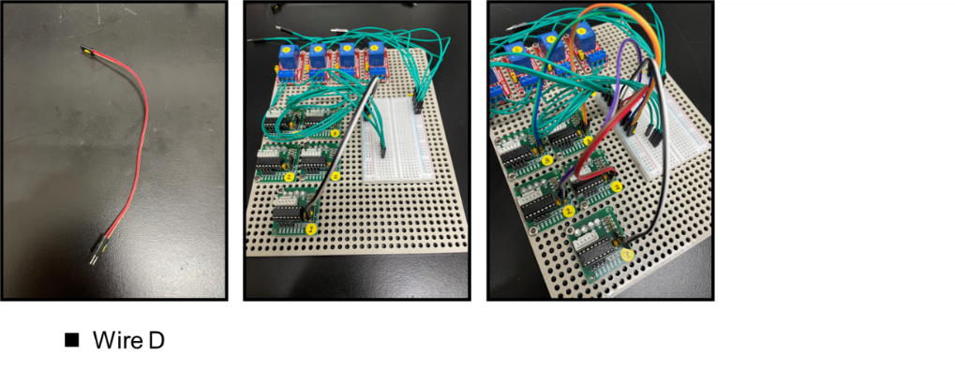

II.

The Raspberry GPIO pins 18, 22, 24 and 26 were connected to input portion of the stepping motor control module via a bread using wire E (bread board pin socket name from i12, i14, i15 and i16 to stepping motor control module1 IN1, IN2, IN3 and IN4) (Fig. 3R and T) (Table. 1A) (Supplementary Fig. 4E). The Raspberry GPIO pins 32, 36, 38 and 40 were connected to input portion of the two stepping motor control modules via a bread using wire E (bread board pin socket name from i19, i21, i22 and i23 to two stepping motor control modules2 IN1, IN2, IN3 and IN4) (Fig. 3P, Q and S) (Table. 1A) (Supplementary Fig. 4E). The Raspberry GPIO pins 7, 11, 13 and 15 were connected to input portion of the stepping motor control modules via a bread using wire E (bread board pin socket name from b7, b11, b13 and b15 to stepping motor control modules3 IN1, IN2, IN3 and IN4) (Table. 1A) (Fig. 3N and O) (Supplementary Fig. 4E).

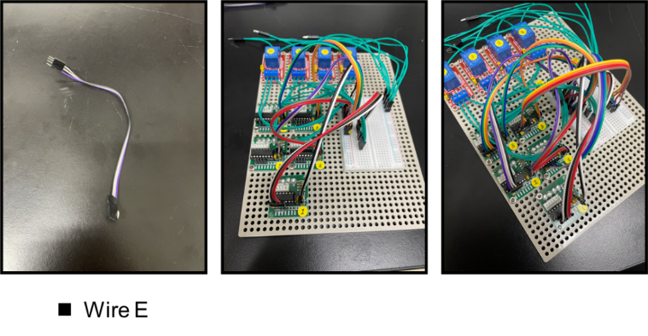

III.

Stepping motor driver modules were connected to the stepping motor using wire F (stepping motor control module1 to stepping motor attached to x axis actuator, two stepping motor control module2 to stepping motors attached to y axis actuators, stepping motor control module3 to stepping motor attached to the filter table and light source table) (Supplementary Fig. 4F).

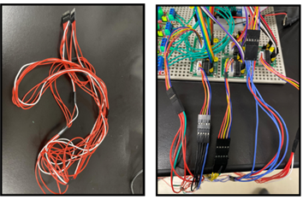

**6. Wiring with power and GPIO pin expansion board**

I.

power source connectors were attached to the bread board (Supplementary Fig. 4H).

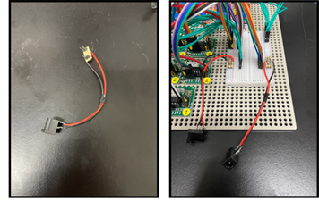

II.

The Raspberry pi GPIO pins were connected to bread board with an expansion board (Fig. 3B and E). Specifically, 3.3v pin of expansion board was connected to d4 on the bread board and GPIO21 pin of expansion board was connected to g23 on the bread board (Supplementary Fig. 4I).

